LAB 3 for Operating Systems

***Name****: Trần Thanh Dương*

***Student’s Code****: SE160185*

***Class****: AI1601*

# Question 1: Present the content of manipulating of some command

* **pstree –np**: pstree shows running processes as a tree. The tree is rooted at either pid or init if pid is omitted. If a user name is specified, all process trees rooted at processes owned by that user are shown. -np means showing PID and sorting processes with the same ancestor by PID instead of by name. (Numeric sort).

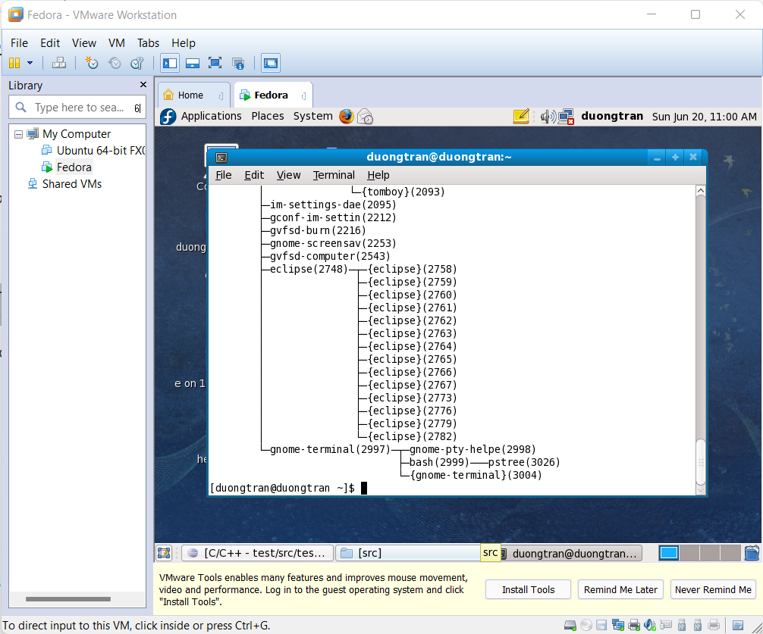

* **pkill**: pkill will send the specified signal to each process instead of listing them on stdout.

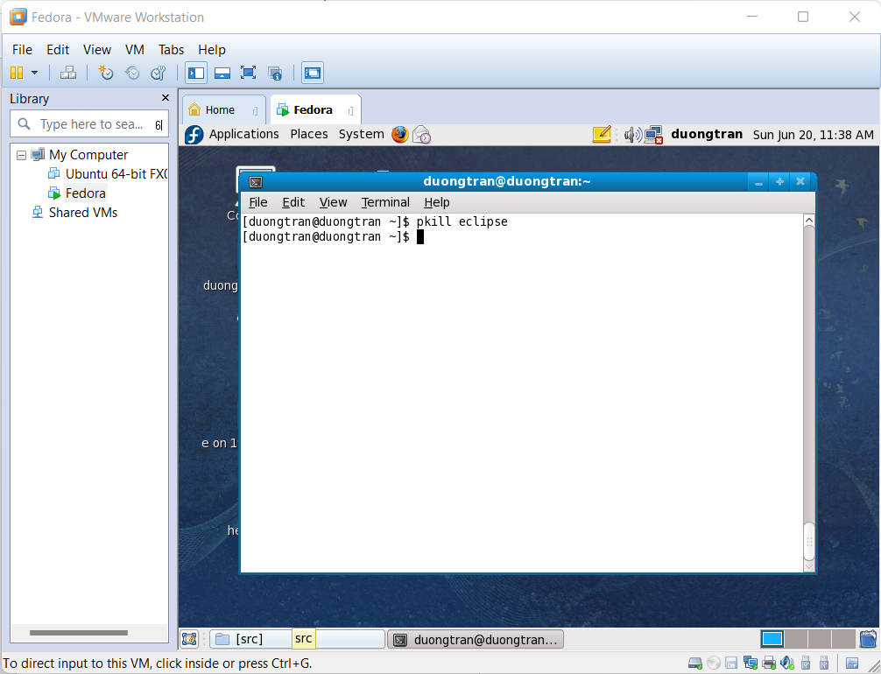

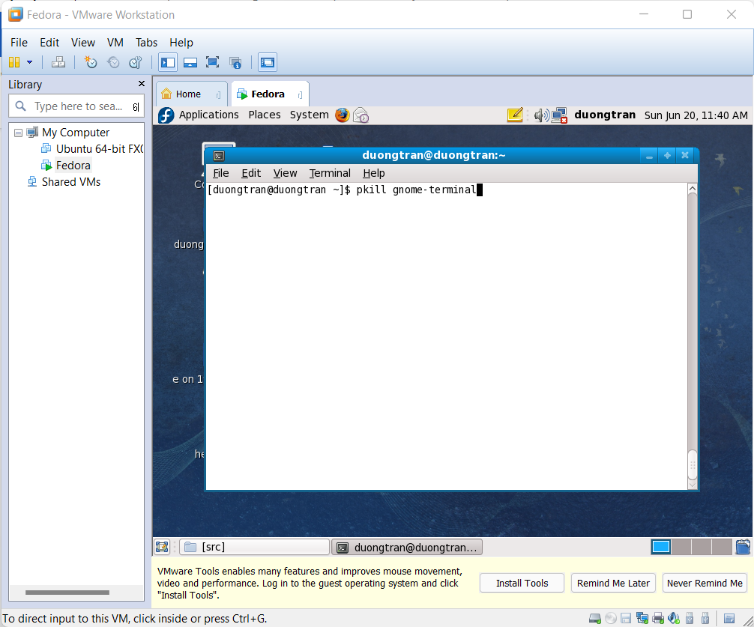

* **uptime**: It is used to find out how long the system is running. This command returns set of values that involve, the current time, and the amount of time system is in running state, number of users currently logged into, and the load time for the past 1, 5 and 15 minutes respectively.

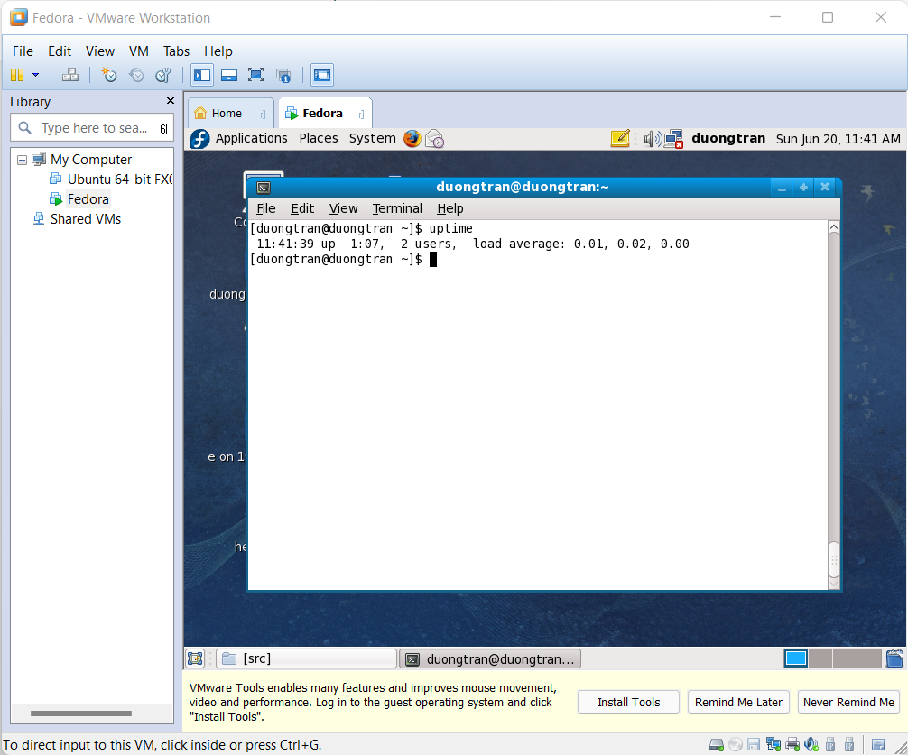

* **free**: displays the total amount of free space available along with the amount of memory used and swap memory in the system, and also the buffers used by the kernel.

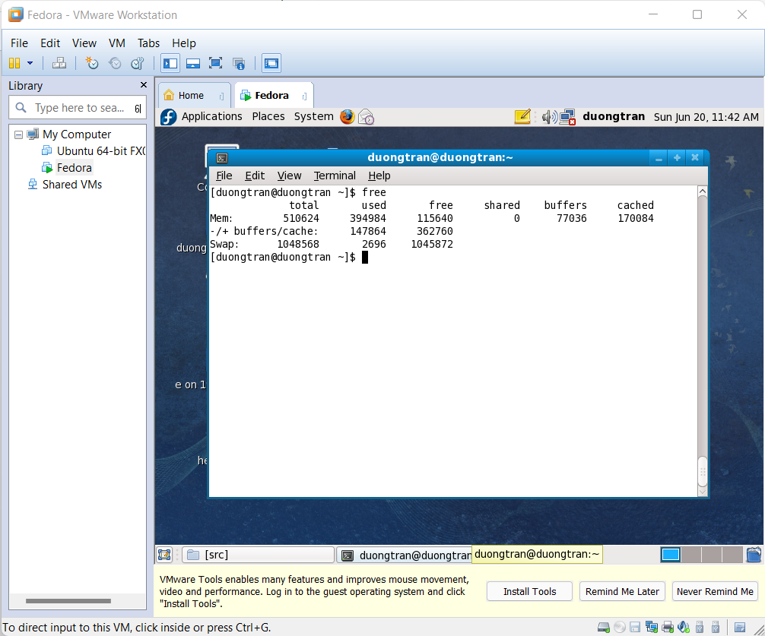

# Question 2: Capture the terminal screen using the “pgrep –u root” command

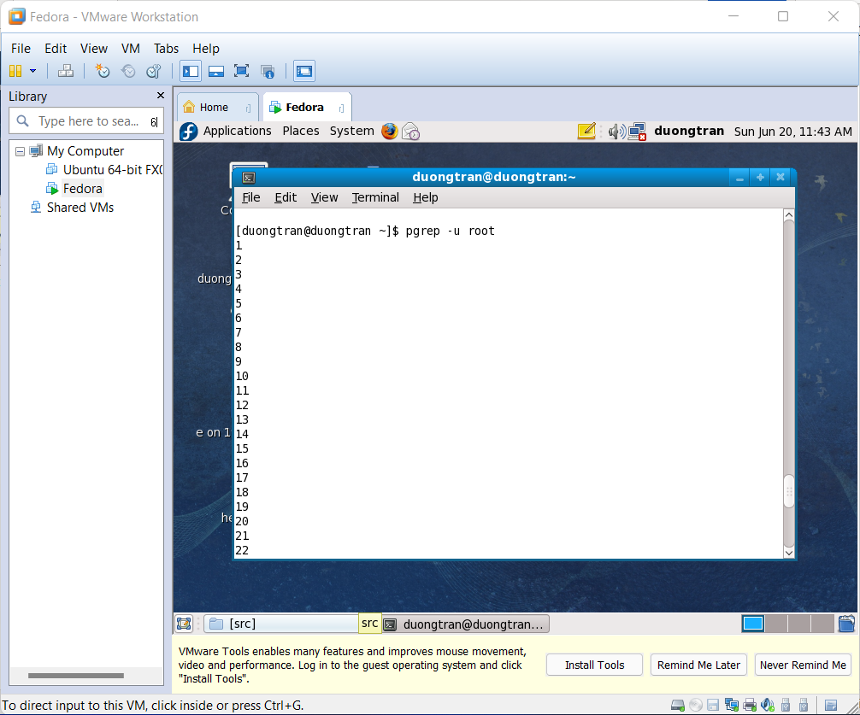

**Explaination**: **prgrep** is a command-line utility that allows you to find the process IDs of a running program based on given criteria. It can be a full or partial process name, a user running the process, or other attributes. We use **-u root** for telling **prgrep** to display processes being run by a given user.

# Question 3: How to open “Task Manager” on Fedora

**Using command line**

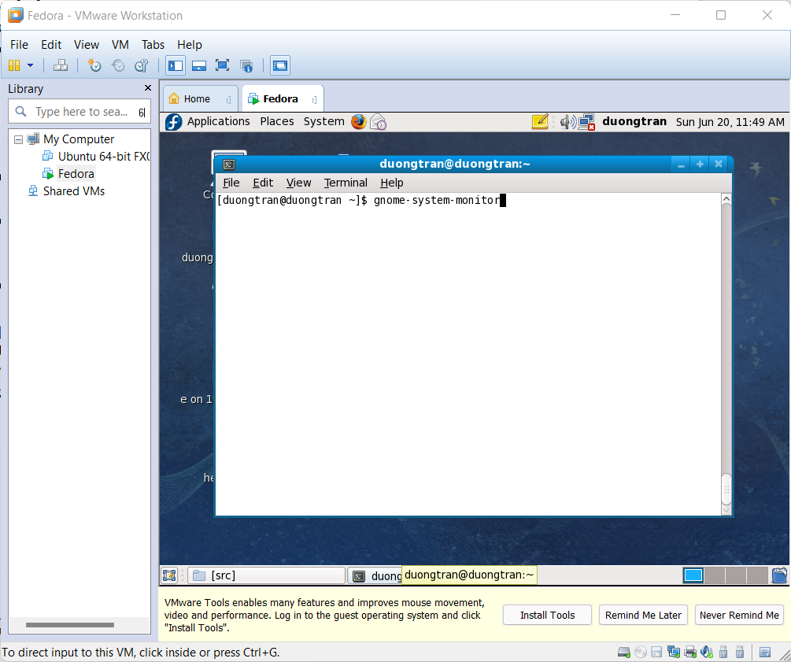

**Using GUI on taskbar**

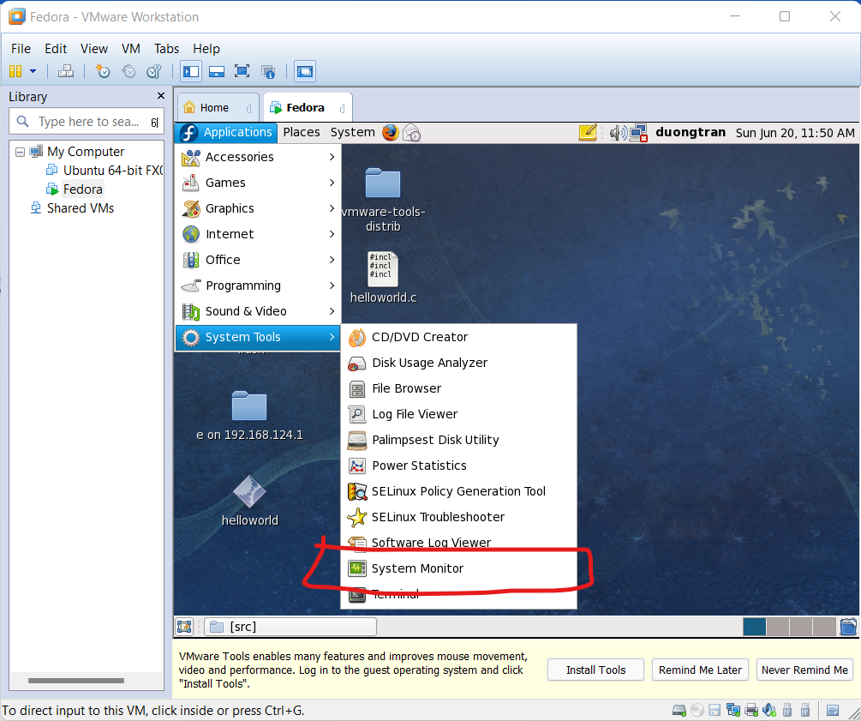

**Result:**

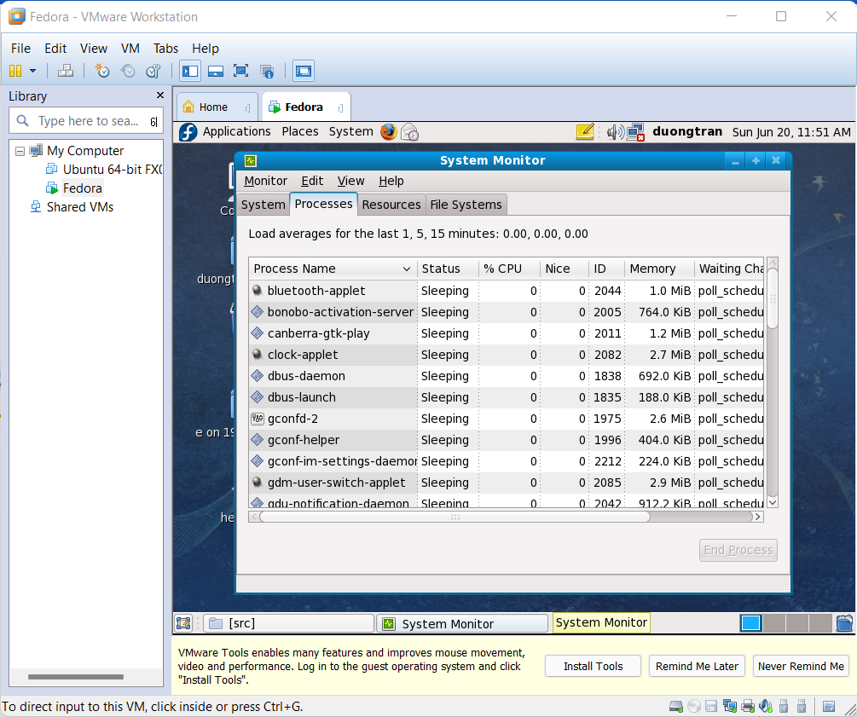

# Question 4: How to open “Add or Remove Software” in Fedora

